**Short biography for**

**Dr. Gad Mohamed El-Qady**

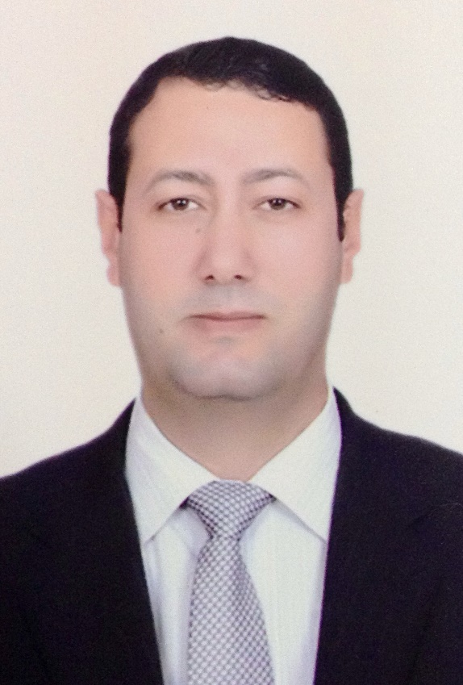

Prof. Gad El-Qady, is a Professor of Applied Geophysics working in the area of application of Geophysical techniques for, but not limited to, Environmental investigations, archaeological, geotechnical, groundwater, geothermal investigations. Prof. El-Qady was working as a president of the National Research Institute of Astronomy and Geophysics (NRIAG) Jan 2019 till March 2024. Between July 2018 till Jan 2019, he was appointed as Vice President of NRIAG. During 2017 he was the acting president of the National Institute of Oceanography and Fisheries (NIOF), Egypt. While during 2013-2014 he was coordinator of the international relations of E-JUST. He also was the science and culture attaché of Egypt in Japan from 2010 to 2013. He got his PhD from Kyushu University, Japan on 2001. Since that time is an active member of the Egyptian Geophysical community. Prof. El-Qady supervised many post graduate students at different Egyptian universities. Prof. El-Qady, is the managing editor of the journal of National Research Institute of Astronomy and Geophysics (NRIAG) and has published many scientific papers, reviews, in peer reviewed international journals among them: archaeology, Earth Planets Space, Journal of African Earth Science, Earth and Planetary Science Letters, ….etc and he participate in several international Conferences and functioning as a referee for international Journals. He also organized several international conferences such as the 20th EMIW, ACAG5th, AFSC2016.

He is also a working group committee member of the Electromagnetic induction in the earth (WMIW) that is now Div No. 6 of the IAGA (2008-2016).

**Awards and activities:**

1. PhD, Engineering geophysics, 2001, MEXT scholarship at Earth Resources and system engineering, Kyushu University
2. JSPS postdoctoral fellowship (2003-2005) at Earth Resources and system engineering, Kyushu University.
3. PI for the project titled” virtual heritage cairo.com” 2015-2019, funded from AHRC, UK, in cooperation with Wolverhampton and Nottingham Trent Universities, UK.
4. PI of project titled” SEALINES Mediterranean Safety Network” funded by (Blue Med, EU, 2019-2020).
5. Co-PI for a project titled” LABYRINTH: Conservation, Analysis and Virtual Reconstruction of Archaeological Site of Hawara Pyramid and Labyrinth (El Fayoum), joint fund STDF-AHRC.

**Some selected publications:**

1. **Gad El-Qady** and [**Claudio Margottini**](https://link.springer.com/book/10.1007/978-3-031-13810-2#author-1-1), 2023, Sustainable Conservation of UNESCO and Other Heritage Sites Through Proactive Geosciences, Editors: Springer, Berlin, Heidelberg. <https://doi.org/10.1007/978-3-031-13810-2>, XI, 734pp
2. Gad El-Qady, Mohamed Metwaly, (2019), [Archaeogeophysics: State of the Art and Case Studies](http://books.google.com/books?hl=en&lr=&id=GNNjDwAAQBAJ&oi=fnd&pg=PR5&dq=info:xDLwaO56kpUJ:scholar.google.com&ots=UMYP7lo0p0&sig=TsXqJ_y6BAofyHontHr6KWTeVJc). Book, springer, 280 pp
3. Tarek Ibrahim, Gouda Dabour, Minghua Ren, Gad El-Qady, Philip Goodell, Ibrahim Gaafar, Luis Sandoval, Munazzam Ali, (2019) [Potential Heavy Mineral-Enriched Black Sand Deposits South Ras Banas Red Sea Coast (Egypt)](https://link.springer.com/chapter/10.1007/978-3-030-01575-6_31), Petrogenesis and Exploration of the Earth’s Interior, pp.129-132
4. M. Abdel Zaher, S. Elbarbary, S.A. Sultan, G. El-Qady, A. Ismael, E.M. Takla (2018). Crustal thermal structure of the Farafra Oasis, Egypt, based on airborne potential field data, Geothermics 75C, 220-234.
5. IM Ibraheem, EA Elawadi, GM El-Qady, 2018, [Structural interpretation of aeromagnetic data for the Wadi El Natrun area, northwestern desert, Egypt](javascript:void(0)), Journal of African Earth Sciences 139, 14-25.
6. IM Ibraheem, G El-Qady, 2018, [Hydrogeophysical Investigations at El-Nubariya-Wadi El-Natrun Area, West Nile Delta, Egypt](javascript:void(0)). Groundwater in the Nile Delta, 235-271.

For full list of Publication:

Google scholar:

<http://scholar.google.com.eg/citations?user=4hE54AEAAAAJ&hl=en>